Useless Lockbox Requirements Specification

Authors: Team 9: Daniel Diaz, Dwayne Hoeck, Ha Tran, Thanh Le

Rev. 0.2

October 22, 2016

Privacy and security have become major concerns in society today. Whether it be a teenager trying to keep a diary hidden or an adult keeping money away from a less than trustworthy roommate, a lockbox is a good way to go. Unfortunately, lockboxes are obvious and sometimes bring with them curiosity as to what is inside. An interesting and elegant way to keep a lockbox without arousing much suspicion is needed.

The objective of this project is to design and prototype an elegant lockbox. The lockbox feature should not be the most distinguishing feature. The lockbox should have some secure way of storing items.

**Functionality:**

* Act as a lockbox being secure with a locking mechanism

**Aesthetics:**

* **Should not automatically appear to be a lockbox**
* **Incorporate a useless machine**

**Economic:**

* Total development budget for the product will not exceed $30.
* Total parts and manufacturing costs cannot exceed $40 per unit.

**Operational Physical Environment:**

* Product will have a stable shape with overall dimensions not exceed 12’ x 12’ x 12’.
* Product’s weight will not exceed 5 lbs for portability.

Our proposed practicum project is the useless lockbox. A useless machine is a device that has no direct purpose. Most useless machines are simple boxes that have a switch and a moving arm. When the switch is flipped by somebody, the arm moves and flips the switch back to the starting position. This feature will be the distinguishing feature making the lockbox itself less noticeable. The switch will enable a keypad and LCD screen. If the correct keycode is entered a solenoid will activate and the “hidden” lockbox compartment will open. If the keycode is incorrect a moving arm will flip the switch back to the off position.

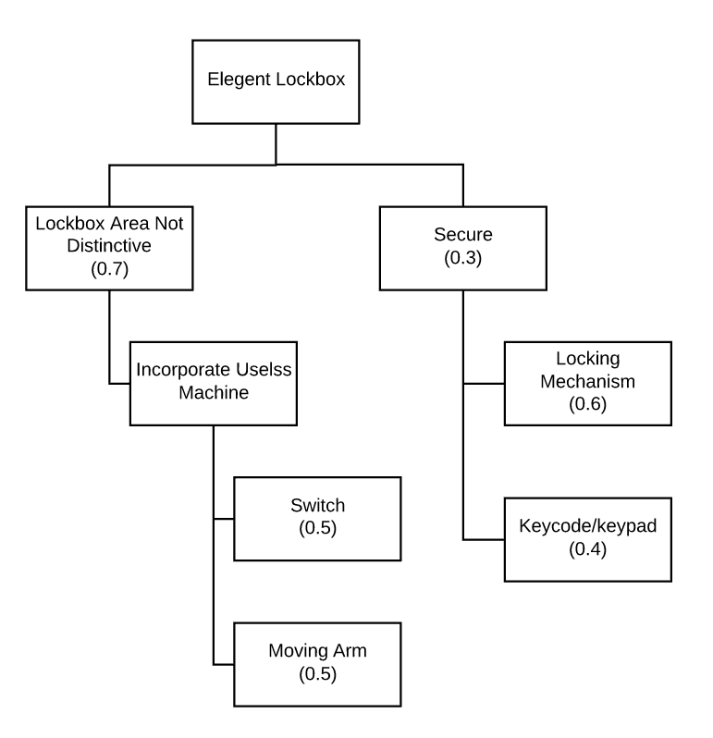

Figure - Decision Tree